**Activity 1. Transformation**

With the following HTML and CSS code, make the next transformations.

<https://codepen.io/paqui-molina/pen/ZmWXdZ>

1. Move the first box 100px to the right, and 50px down from its original position.
2. Increase the size of the second box, making it twice as large.
3. Rotate the third box 45º, both from its coordinate center and from the upper left corner.
4. Create a parallelogram with the fourth box, which angle of inclination is 25º.

**Activity 2. Transitions**

Make the necessary transitions to move boxes from the initial state to the end

<https://codepen.io/paqui-molina/pen/YRqEZx>

1. Rotate 270º.
2. Exchanges the positions of the boxes 1 y 2, 3 y 4.
3. Resize from 100px to 50px.
4. Change backgrouncolor from blue to red .
5. Change color from black to yellow.
6. Change font size from 20px to 18px.

for each case use a different duration and function of time

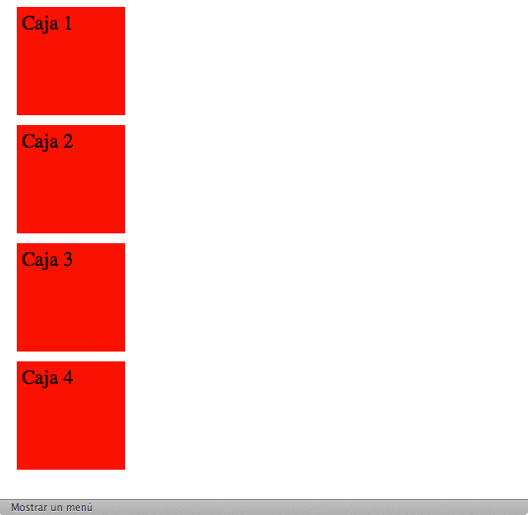  
Figure 1: before transition

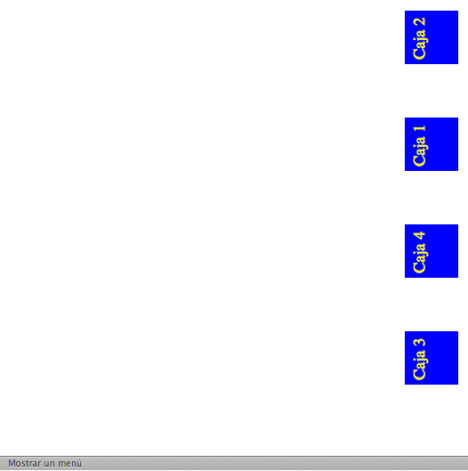  
Figure 1: figure transition

**Activity 3. Animations**

Make the necessary animations to simulate a snow effect. Use at least two animations:

1. The first to simulate the fall of snowflakes.
2. The second to make disappear the flakes as they reach the ground, using the *opacity* property.

The animation must run infinitely.

<https://codepen.io/paqui-molina/pen/yQOPme>